Hadoop-Based Data Lake Architecture for Enterprise Migration

Introduction :-

Many organizations are moving from traditional on-premise data warehouse to Hadoop-based data lakes. This approach supports large-scale storage and distributed processing by separating storage, resource management, and computation into different layers. In this architecture, HDFS stores the data, YARN manages the cluster resources, and MapReduce process the data in parallel. Figure 1 shows the overall structure of the Hadoop-based data lake.

HDFS Storage Layer :-
HDFS stands for Hadoop Distributed File System. It is responsible for storing large files across multiple machines in a cluster. The NameNode manages metadata such as filenames, permissions, and block locations, while the DataNodes store the actual file blocks. HDFS improves reliability by splitting data into blocks and replicating them across multiple nodes so that the system can tolerate failures and continue operating.

YARN Resource Layer

YARN stands for Yet Another Resource Negotiator. It manages resources across the Hadoop cluster and allows different applications to share the same infrastructure. The ResourceManager performs cluster-level scheduling, while NodeManagers run on worker nodes and manage application containers. This design helps multiple workloads such as Spark, Hive, and MapReduce use the same cluster efficiently without needing separate hardware for each tool.

MapReduce Processing Layer:-

MapReduce is Hadoop’s processing model for distributed data analysis. It works in three main phases:Map, Shuffle, and Reduce. In the Map phase, input data is converted into key-value pairs. In the Shuffle phase,
matching keys are grouped together. In the Reduce phase, the grouped values are aggregated to produce the final output. A common example is the word count job, where each word is emitted with a value of 1 and then summed to get the final count.

Data Flow Explanation: -

When a 1 GB CSV file is uploaded to HDFS, It is divided into smaller blocks, typically 128 MB each, and stored across different DataNodes. If the replication factor is 3, each block is copied to three locations to improve fault tolerance. When a MapReduce job runs on this file, YARN allocates resources, Map tasks process input in parallel, Shuffle groups identical keys, and Reduce produces the final output file. This flow shows how Hadoop handles both storage and processing at scale.

Figure 1 : Hadoop architecture diagram

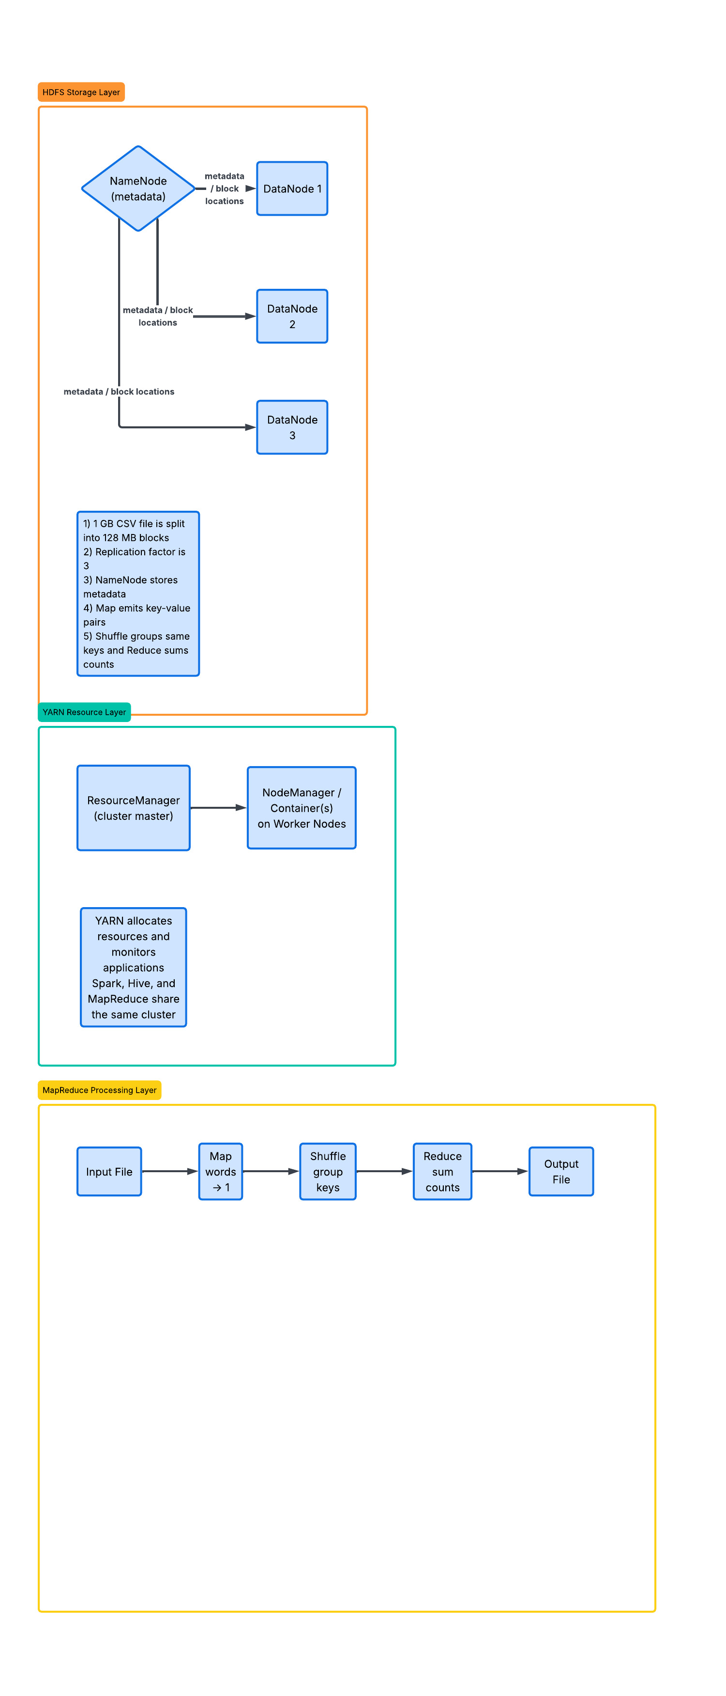

Executive Summary :

YARN plays a key role in making Hadoop practical for modern enterprise environments. Its separates resource management from data processing so that multiple applications can run on the same cluster without conflict.
The ResourceManager decides how resources are assigned, and NodeManagers monitor the containers running on worker nodes. This allows Spark, Hive, and MapReduce to share the same cluster while making better use of available hardware. As a result, organizations reduce infrastructure cost, improve utilization, and gain flexibility in running different analytics workloads on the same data platform. YARN is therefore one of the most important components in Hadoop-based data lake architecture.

Conclusion :

Hadoop provides a scalable and fault-tolerant foundation for a data lake migration. HDFS stores data in distributed blocks, YARN manages cluster resources, and MapReduce processes data in parallel across multiple machines. Together, these components create a flexible platform that supports large scale storage, efficient processing, and shared use of computing resources. The architecture is suitable for enterprise that need to modernize their data infrastructure and support multiple analytics workloads on the same cluster.

Apache Hadoop Word Count and MapReduce concepts are based on standard Hadoop processing flow.

